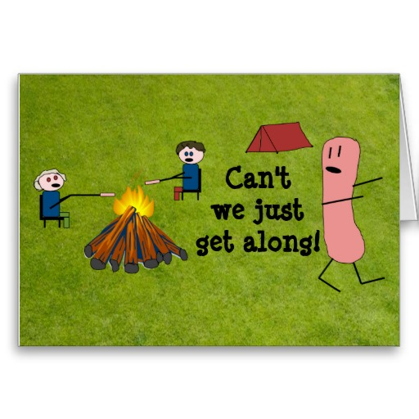
AMC Inter-Chapter Paddling Trip
AMC NY-NJ Dope Sheet
Deerfield River: Fife Brook / Dryway Trips
August 2-4, 2013
Leaders:
AMC Inter-Chapter Paddling Committee
- Carin Tinney, waterbabynyc@aol.com, River Leader/IPC Liaison, 908-303-4945
- Rob Holbrook, Holbrook_rob@hotmail.com, River Leader, 347-603, 6749
- Olly Gotel, Leader in Training, olly@gotel.net, River Leader/LIT, 646-701-1259
- David Michael, Leader in Training, david@davidmichael.org, LIT, 201-456-7057
- Andrew LoPinto, Registrar, Dryway Newbie (wish him luck!), andrewlopinto@gmail.com

Welcome:
This is the first Inter-Chapter Paddling Trip at the Deerfield (at least in recent years), so I’m crossing my fingers it will be successful! We are joining up with several other AMC chapters for a big cookout on Saturday, paddling Saturday and Sunday, and camping. You may be getting multiple dope sheets, but that’s okay. Here are the essentials of what we are doing together:

Paddling:
- Boston and Connecticut chapters will be leading the Fifebrook trips on Saturday and Sunday.
- NY-NJ chapter will be leading the Dryway trips on Saturday and Sunday.
- Worcester chapter will be leading a family-friendly class one trip on the Shunpike on Saturday afternoon.

Eating:
- Why on earth did I put eating second? Oh wait, I’m a paddler…duh!
- Breakfasts and lunches, and Friday dinner are all on your own.
- We will provide coffee/tea on Saturday and Sunday morning.
- We will have a big cookout with all the chapters on Saturday night (Saint Julia is bringing BBQ food, we just have to cook it). PLEASE, PLEASE, PLEASE lend a hand… it doesn’t happen on its own.
- Saturday Happy Hour will be at the campground, so bring something to share!
- Bring beverages of your choice… see below.
- Please bring plates, cups, knives, forks, napkins, doilies, mug, sippy cup, whatever it takes for you to bring the food from the fire to your mouth, bring it! We won’t be supplying paper products.

Drinking:
Drinking is ALLOWED at the campsite. Holy sh*t! Yes, we have a campground that allows you to partake in alcoholic beverages. We’ll need it for all the booty beers our newbies are going to down after their Dryway runs

Camping:
- We are staying at Country Aire Campground on Rt. 2.
- We are in the open field.
- You will pay the banker on Sunday morning all fees associated with the campground.
- We have it available Friday and Saturday night. Contact them directly if you are planning on staying Thursday night.

Directions to the Campsite:
See the map attached to this dope sheet, but it’s best that you look this up, as I’ve gotten people lost before.
Here is the Campground’s website: http://www.countryairecampground.com/ (don’t freak out, the website sings).

Costs:
- We are estimating that camping will be $10/per night per person.
- Food will be anywhere between $5-$15, so sorry for the wide range. It will likely be closer to the lower range.
- NY-NJ is WAIVING its trip fees, but any/all donations to the IPC (e.g. IPC often pays for New Boston Legion Hall rental) are welcome.

Meeting Time and Place:
We have not determined every river trip’s meet up/put-in times yet. But here are some helpful tips:
- For the Dryway trip, be ready to shuttle to the Dryway by 8:30am each day. There is a bridge problem at Monroe… we can’t go over it, which makes for some chaotic shuttling the later it gets.
- The Fifebrook usually releases around 11 am… so try to be ready to go by 9:30am—CHECK with the other groups when you get there (sorry introverts, that means you might actually have to talk to someone :0)!!!)

Waterline Flowcast: 1-800-452-1737 Boater's Edition:
- Fife Brook - Site Code 255123
- #5 Bypass (Monroe Bridge) - Site Code 255122

Route 2 Tip:
DO NOT SPEED along Rt. 2. It is patrolled heavily by State Police AND local police.
The Mohawk Trail State Forest Campground is 4 miles west of Charlemont, MA.

Transportation:
You are responsible for your own transportation. If you do not have a car, check the list of participants to see who is offering a ride and contact those people directly and check their availability to arrange a meeting place. The AMC suggests figuring out a formula to cover costs, or just take turns filling the tank. Alternatively, a group of you might split the cost of a rental car. Your leaders will NOT get involved with any of these arrangements.

Risk:
Paddling is a risk sport. You alone assume responsibility for your own safety and equipment. You must be both physically and mentally prepared and be equipped with the appropriate gear. Only you can judge your skills relative to the conditions found on the river (or other body of water) and any possible risk. You alone are ultimately responsible for your decision to paddle or not, and for your own safety.

AMC policy requires that all participants sign the club’s Volunteer Release Agreement (aka the Waiver) before participating in club activities. A copy of the waiver may be found at:
www.outdoors.org/pdf/upload/volrelease.pdf

SIGN a WAIVER. All the waivers go to the SAME place. So if you do not sign NY-NJ’s, sign CT’s or MA’s. But please sign one, even if you are not paddling with us, and just hanging out because we are so cool, you are officially on the trip, so please sign the waiver. Thanks! Most accidents (if you aren’t me) happen OFF the river.

Local Hospital:
The nearest hospital is the North Adams Regional Hospital. Directions from Rt. 2 are as follows:
- Route 2 into North Adams.
- Turn at Dunkin’ Donuts (turn right coming from the east, turn left coming from the west). You are now on Eagle Street.
- Head straight up Eagle Street, through the light at River Street.
- Continue straight.
- Bear left near the top of the hill (hospital sign).
- First left is Hospital Avenue (hospital is located on the right); first driveway is exit for hospital. Continue to second driveway, which is the main entrance. Turn into main drive.

Patient and visitor parking are in the main lot on the right. Emergency parking is straight ahead.

Conservation:
Our rivers will remain unspoiled only if cared for by all who use them. AMC members are expected to set an example for minimum-impact use. By participating in this trip, you agree to try to leave behind no signs of your presence.

Do not transport firewood across state lines. You may be carrying invasive species that will mess up what we like.

Registered for the Dryway:

First |  | Last |  | Email |  |  |  | Street |  |  |  |  | City |  | State | Zip | Cell Phone | Arrival Time | Transport Status
Stephene |  | Kelley |  | sck1218@optimum.net |  |  |  | 259 Hyatt |  |  |  |  | Yonkers |  | NY | 10704 | 5038601971 | Friday before dinner | Has car
Sozanne |  | Solmaz |  | ssolmaz@rockefeller.edu |  |  |  | 500 East 63rd Street Apt 4E |  |  |  |  | New York |  | NY | 10065 | 9173701591 | Unsure at this time | Needs ride
Donna |  | Morgan |  | tenkmaniacs@yahoo.com |  |  |  | 229 Drift Avenue |  |  |  |  | Lawrenceville |  | NJ | 8648 | 9082168940 | Friday night | Has car
Anthony? |  | Meli |  | anthonyjmeli@gmail.com
David |  | Michael |  | david@davidmichael.org |  |  |  | 720 Greenwich Street |  |  |  |  | New York |  | NY | 10014 | 2014567057 | Friday evening – NOT camping | Car pool with Olly
Olly |  | Gotel |  | olly@gotel.net |  |  |  | 720 Greenwich Street |  |  |  |  | New York |  | NY | 10014 | 6467011259 | Friday evening – NOT camping | Car pool with Dave
Paul |  | Potochniak |  | bpp13905@gmail.com |  |  |  | 379 Meadowood Road |  |  |  |  | Jackson |  | NJ | 8527 | 9088900323 | Friday night | Has car
Andrew*? |  | LoPinto |  | andrewlopinto@gmail.com
Denise |  | Gravatt |  | denise.robinson-gravatt@pfizer.com |  |  |  | 250 Grassy Hill Road |  |  |  |  | Lyme |  | CT | 6371 | 8606250789 | Saturday morning | Car pool with Scott
Scott |  | Gravatt |  | denise.robinson-gravatt@pfizer.com |  |  |  | 250 Grassy Hill Road |  |  |  |  | Lyme |  | CT | 6371 | 8606250789 | Saturday morning | Car pool with Denise
Matthew |  | Theisz |  | matt@theisz.org |  |  |  | 74 Salem Road |  |  |  |  | Township of Washington |  | NJ | 7676 | 4123342598 | Friday night | Has car – offers ride
Rob |  | Holbrook |  | holbrook_rob@hotmail.com |  |  |  | 100 Atlantic Ave #2J |  |  |  |  | Brooklyn |  | NY | 11201 | 3476036749 | Friday night | Has car – offers ride
Carin? |  | Tinney |  | waterbabynyc@aol.com
Carin? |  | Cookman |  | carincook@cox.net
Rich? |  | Casten |  | carincook@cox.net

* New to the Dryway.
? Full details not available in the AMC registration list
Maybes:
- Loretta Brady (Fife) - lorettajbrady@hotmail.com
- Bill Handworth (Dryway) - snake311@optonline.net
- Cameron Klinger (Dryway) - ctk117@gmail.com
- Kerri Klinger (Fife) - kerribeth34@yahoo.com
- Chris Viani (Dryway) - cwviani@gmail.com
- Jordan Yaruss (Dryway) - jyaruss@gmail.com
- Marina Zoubtsova (?) - mzoubtsova@gmail.com

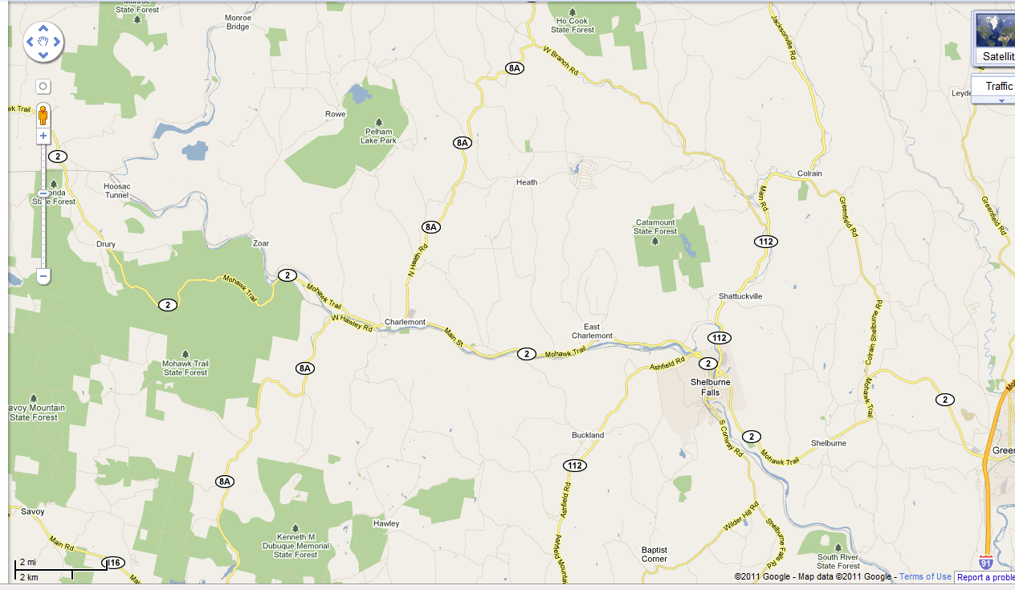
Campsite
CAMPSITE
Fifebrook Takeout
Dryway Takeout
Fifebrook Putin
Dryway Putin
Friday Night Lake Practice

